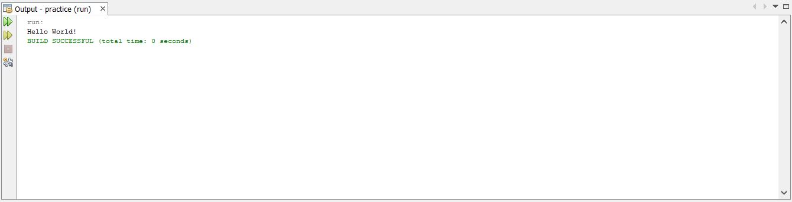
Program 1

Objective : Understanding the basics of programming.

Task : To print “Hello World” as output.

Code:
public class helloworld {

public static void main(String[] args) {
System.out.println("Hello World!");
}
}

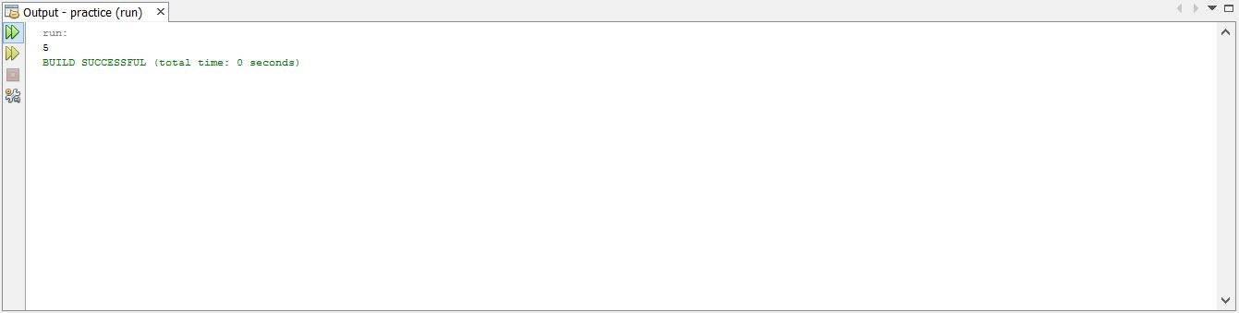
Program 2

Objective : Understanding the use of mathematical operators.

Task : To print the sum of two nos.

Code:
public class adding {

public static void main(String[] args) {
int a =2;
int b =3;
System.out.println(a+b);

}

}

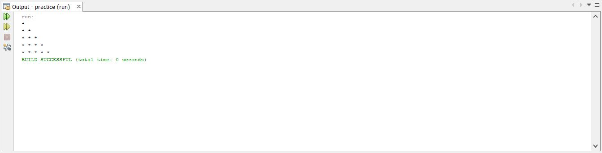
Program 3

Objective: Understanding the use of loops.

Task : To print the character ‘*’ in pattern.

Code:
public class nestedloop {
public static void main(String[] args)
{
int i, j;
for(i=0; i<5; i++)
{
for(j=0; j<=i; j++)
{
System.out.print("* ");
}
System.out.println();
}
}
}

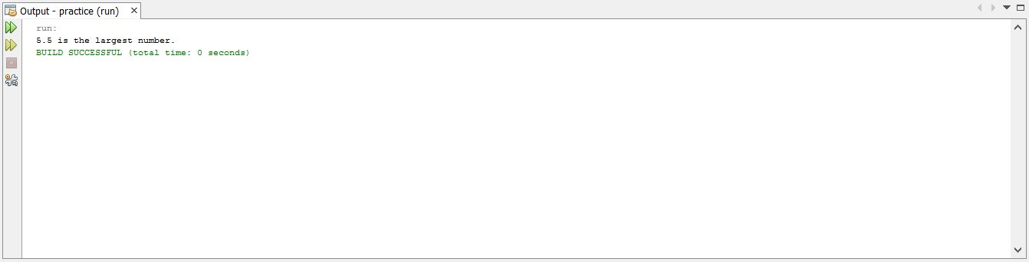
Program 4
Objective : Understanding the use of relational operators.

Task : To find the greatest numbers of given 3 numbers.

Code:
public static void main(String[] args) {
double n1 = -4.5, n2 = 3.9, n3 = 5.5;
if(n1 >= n2) {
if(n1 >= n3)
System.out.println(n1 + " is the largest number.");
else
System.out.println(n3 + " is the largest number.");
} else {
if(n2 >= n3)
System.out.println(n2 + " is the largest number.");
else
System.out.println(n3 + " is the largest number.");
}
}

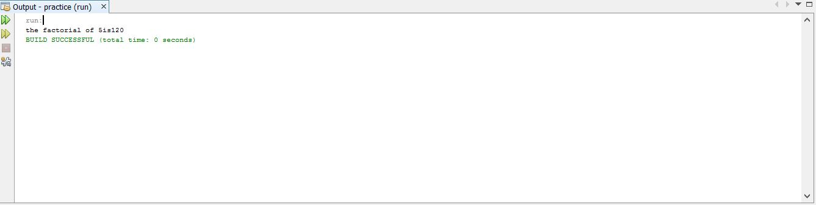

Program 5

Objective : Understanding the use of loops.

Task : To calculate factorial of a natural number.

Code:
public class factorial {
public static void main(String[] args){

int num=5;
long i=0,fact=1;
i = num;
while(num !=0) {
fact = fact*num;
--num;
}
System.out.println("the factorial of "+i+"is"+fact);
}
}

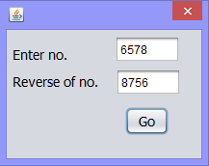
Program 6

Objective : Understanding the use of loops.

Task : To display the reverse of a number.

Code:
int n1=Integer.parseInt(ta1.getText());
int rev=0;
while(n1>0)

{int digit=n1%10;
rev=rev*10 + digit;
n1=n1/10;
ta2.setText(""+rev);
}

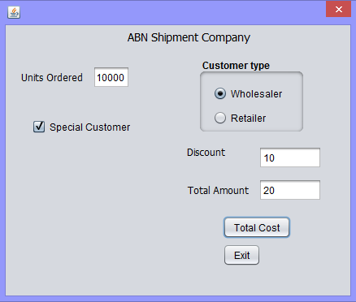
Program 7

Objective: Understanding and developing a logic to solve a problem. Understanding and use of Nested conditions in the Real life applications.

Task : To develop an app that calculates discount and net amount for a company.

Code behind Total Cost button:
int no=Integer.parseInt(units.getText());
int p=0;
if(no>=1 && no<=15)
{ p=w.isSelected() ? 50:60;}

else if(no>=16 && no<=20)
{ p=w.isSelected() ? 45:55;}

else if(no>=21 && no<=30)
{ p=w.isSelected() ? 40:50;}

else if(no>=31 && no<=50)
{ p=w.isSelected() ? 35:45;}

else if(no>50)
{ p=w.isSelected() ? 30:40;}

int disc=spl.isSelected() ? 10:0;
int totl=p-disc;
total.setText(""+totl);
discount.setText(""+disc);

Code behind Exit button:
System.exit(0);

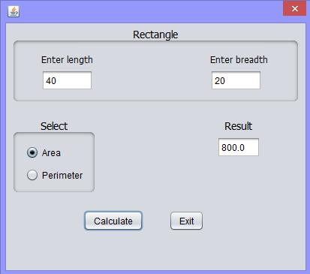
Program 8

Objective: Use of JPanel in real life .

Task: Develop a Java Desktop Application using class the implement the rectangle class & calculate the area & perimeter of a rectangle.

Code behind Total Calculate button:
Double l=Double.parseDouble(length.getText());
Double b=Double.parseDouble(breadth.getText());

Double r;
if(ar.isSelected())
r=l*b;
else r=2*(l+b);

result.setText(""+r);

Code behind Exit button: System.exit(0);
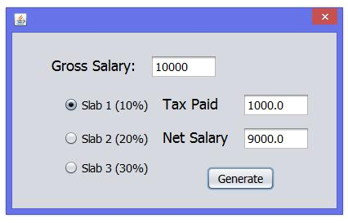
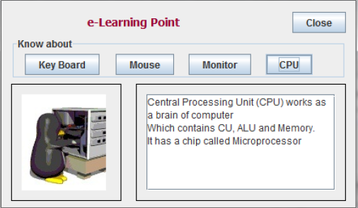
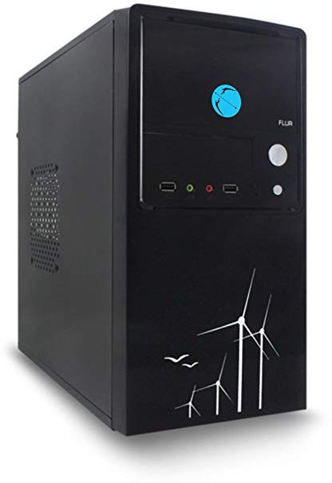
Program 9

Objective: Displaying images on a Label and Text Area control.

Task: Develop an e-learning application with images and text information.

Code behind CPU button:
private void jButton5ActionPerformed(java.awt.event.ActionEvent evt) {

ta.append("Central Processing Unit(CPU) works as the brain of the computer."+'\n');

ta.append("It contains ALU, MU and CU."+'\n');

ta.append("It has a chip called microprocessor"+'\n');

image.setIcon(new

ImageIcon("C:\\Users\\user\\downloads\\cpu.jpg"));

}

Code behind Mouse button:
private void

jButton3ActionPerformed(java.awt.event.ActionEvent evt) {

ta.append("A computer mouse is a hand-held pointing device that detects two-dimensional motion relative to a surface."+'\n');

ta.append("This motion is typically translated into the motion of a pointer on a display,"+'\n');

ta.append("which allows a smooth control of the graphical user interface."+'\n');

image.setIcon(new

ImageIcon("C:\\Users\\user\\downloads\\cpu.jpg"));

}

Code behind Monitor button:
private void

jButton4ActionPerformed(java.awt.event.ActionEvent evt) {

ta.append("A computer monitor is an output device which displays information in pictorial form."+'\n');

ta.append("A monitor usually comprises the display device, circuitry, casing, and power supply."+'\n');

image.setIcon(new

ImageIcon("C:\\Users\\user\\downloads\\monitor.jpg"));

}

Code behind Keyboard button:
private void

jButton2ActionPerformed(java.awt.event.ActionEvent evt) {

ta.append("In computing, a computer keyboard is a typewriter-style device which uses an arrangement"+'\n');

ta.append("of buttons or keys to act as mechanical levers or electronic switches.");

ta.append("Following the decline of punch cards and paper tape, interaction via");

ta.append("teleprinter-style keyboards became the main input method for computers.");

image.setIcon(new

ImageIcon("C:\\Users\\user\\downloads\\keyboard.jpg"));

}

Code behind Close button:
System.exit(0);

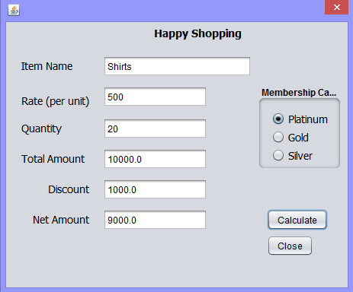
Program 10

Objective: Understanding and using the Radio Button in Real-life application to determine the selection of choice and calculations accordingly.

Task: Develop a Billing application for Happy Shoping- A retail chain involved in sales of Readymade garments. The happy Shoping offers discount to its members holding Platinum, Gold and Silver card. The 10% discount is given to Platinum card, 8% to Gold Card and 5% to Silver Card holders on sales amount.

Code behind Calculate button:
Double r=Double.parseDouble(rate.getText());
Double n=Double.parseDouble(quantity.getText());
Double totl=r*n;
total.setText(""+totl);
Double disc=1.0;

if(platinum.isSelected())
disc=0.1*totl;

else if(gold.isSelected())
disc=0.08*totl;

else if(silver.isSelected())
disc=0.05*totl;

discount.setText(""+disc);
Double amt=totl-disc;

net.setText(""+amt);

Code behind Close button:
System.exit(0);

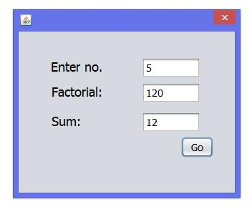
Program 11

Objective : Understanding the use of loops.

Task : Develop an application to calculate sum of n natural nos. and factorial of no.

Code:
int i, f=1, s;

Int n=Integer.parseInt(n1.getText()); {for (i=1; i<=n; i++) f=f*i;

factorial.setText(""+f);}

{s= n/2*(n+1);

sum.setText(""+s);

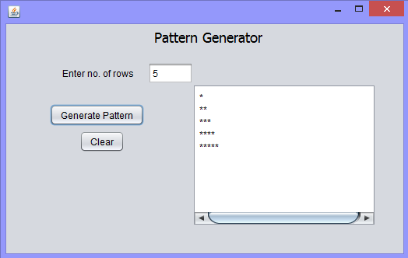
Program 12

Objective: Understanding the looping concept for pattern generation.

Task: Develop an application to display star pattern.

Code behind generate pattern:
int rows= Integer.parseInt(tf.getText());

for(int i=1;i<=rows;i++)
{
for (int j = 1; j <= i; j++)
{
ta.append("*");
}
ta.append(""+'\n');
}
Code behind generate pattern:
ta.setText(null);

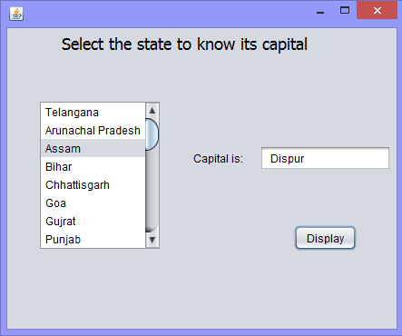
Program 13

Objective: Understanding and using JLists in Real-life application to determine the selection of choice and display result accordingly.

Task: Using List Box control to show the list of states & display the Capital of the selected state.

Code:
int i = list1.getSelectedIndex ();
String name = null;
switch (i)
{
case 0 : name = (" Hyderabad ");
break;

case 1 : name = (" Itanagar ");
break;

case 2 : name = ( " Dispur ");
break;

case 3 : name = ( " Patna ");
break;

case 4 : name = (" Raipur ");
break;

case 5 : name = (" Panaji");
break;

case 6 : name = (" Ahmedabad ");
break;

case 7 : name = (" Chandigarh ");
break;

case 8 : name = (" Shimla ");
break;

case 9 : name = (" Srinagar");
break;

case 10 : name = (" Ranchi");
break;

case 11 : name = (" Bangalore");
break;

case 12 : name = (" Thiruvananthapuram ");
break;

case 13 : name = (" Bhopal");
break;

case 14 : name = (" Mumbai");
break;

case 15 : name = (" Imphal");
break;

case 16 : name = (" Shillong");
break;

case 17 : name = (" Aizawl");
break;

case 18 : name = (" Kohima");
break;

case 19 : name = (" Bhubaneshwar");
break;

case 20 : name = (" Chandigarh");
break;

case 21 : name = (" Jaipur");
break;

case 22 : name = (" Gangtok");
break;

case 23 : name = (" Chennai");
break;

case 24 : name = (" Agartala");
break;

case 25 : name = (" Lucknow");
break;

case 26 : name = (" Dehradun");
break;

case 27 : name = (" Kolkata");
break;

default: name = null;
}
t1.setText(" " + name);

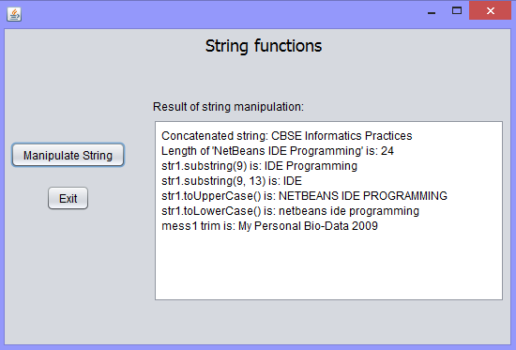
Program 14

Objective: Using String library functions .

Task: Develop an Application which takes a string from the user and displays the result using different string functions.

Code on Manipulate String:
String Board = "CBSE";
String str = " Informatics Practices";
Board = Board.concat(str); // Concatenate str with Board
String str1 = "NetBeans IDE Programming";
int ln = str1.length();
String nStr = str1.substring(9); // Index starts from 9th position
String nStr1 = str1.substring(9, 13); // Index start from 9th position till 13th
String uCase = str1.toUpperCase(); // Converts into uppercase letters
String LCase = str1.toLowerCase(); // Converts into lowercase letters
String mess1 = " My Personal Bio-Data ";
String Year = "2009";
String nTrim = mess1.trim() + " " + Year;
ta.append("Concatenated string: " + Board + "\n");
ta.append("Length of '" + str1 + "' is: " + ln + "\n");
ta.append("str1.substring(9) is: " + nStr + "\n");
ta.append("str1.substring(9, 13) is: " + nStr1 + "\n");
ta.append("str1.toUpperCase() is: " + uCase + "\n");
ta.append("str1.toLowerCase() is: " + LCase + "\n");
ta.append("mess1 trim is: " + nTrim + "\n");

Code on Exit:
System.exit(0);

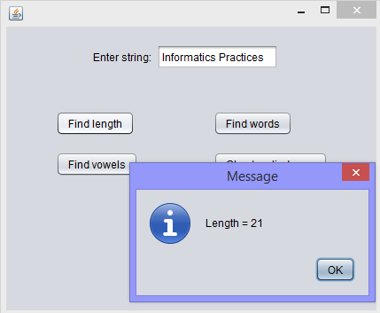
Program 15

Objective: Using String library functions .

Task : Develop an application to accept a String and perform following functions :- (1) find length of the string (2) find no of words in it (3) find string is palindrome or not (4) find number of vowels in it. All output to be displayed using JOptionPane.

Code behind Find length:
String str = strtf.getText();
JOptionPane.showMessageDialog(rootPane, "Length = " + str.length());

Code behind Find words:
String str = strtf.getText();
int s = 1 ;
for(int i = 0;i<str.length();i++)
{
if(str.charAt(i) == ' ')
{
s++ ;
}
}
JOptionPane.showMessageDialog(rootPane, "N.of word = " + s);

Code behind Find vowels:
String str = strtf.getText();
int i ;
int vowel = 0;
for(i = 0; i<str.length(); i++)
{
switch(str.charAt(i))
{
case 'A' :
case 'E' :
case 'I' :
case 'O' :
case 'U' :
case 'a' :
case 'e' :
case 'i' :
case 'o' :
case 'u' : vowel++ ;
}
}
JOptionPane.showMessageDialog(rootPane, "N.of vowels are = " + vowel);

Code behind Check Palindrome:
String str = strtf.getText();
int i = 0; int j = str.length()-1;
int flag = 0 ;
while(i < str.length()/2)
{
if(str.charAt(i)!= str.charAt(j))
{
flag = 1 ;
break;
}
else
{
i++;
j--;
}
}
if(flag ==1)
{
JOptionPane.showMessageDialog(rootPane, "It is not a palindrome");
}
else
{
JOptionPane.showMessageDialog(rootPane, "It is a palindrome");
}

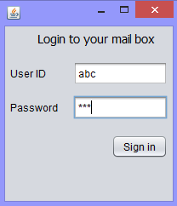
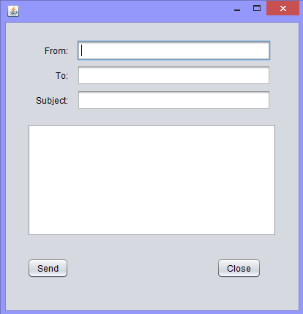
Program 16

Objective: Developing Multi-Frame Application using JDialog Control.

Task: Develop an e-Mail sending Application which facilitates the login and composing screen as given below. A Message box also displayed with proper message when invalid password is given by user and when mail is sent after pressing Send button.

Code on Sign in:
email_compose obj=new email_compose();
String uname="abc";
String pass="def";
String un=username.getText();
String pw=password.getText();

if(un.equals(uname) && pw.equals(pass))
{ obj.setVisible(true);
this .dispose();}

Code on Send:
JOptionPane.showMessageDialog(null,"Sent!");
this.dispose();

Code on Close:
System.exit(0);

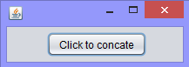
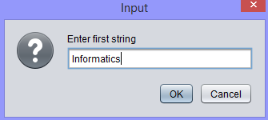
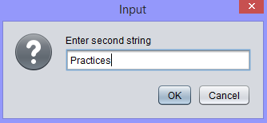
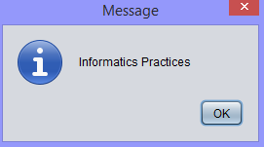
Program 17

Objective: Understanding and use of Java‟s String functions and understanding use of Input dialog window and Message Dialogue window in real life.

Task: Develop an application which takes strings as input from two different Input Dialog windows and write a code to display the concatenated strings in Message Dialog Box.

Code:
String str1 = JOptionPane.showInputDialog("Enter first string ");
String str2 = JOptionPane.showInputDialog("Enter second string ");

JOptionPane.showMessageDialog(this, str1 + " " + str2);

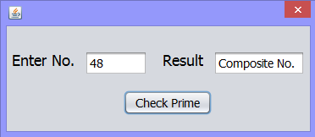
Program 18

Objective: Understanding the use of loops.

Task : Develop an application which takes number as input and checks if it is prime or composite.

Code:
int i;
int n=Integer.parseInt(ta1.getText());
for(i=2; i<n; i++)
if(n%i==0)
{ta2.setText("Composite No.");
break;}
else if(i==(n-1))
{ta2.setText("Prime No.");
}

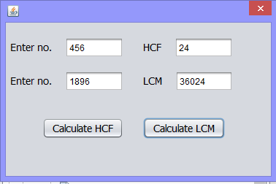
Program 19

Objective: Understanding the use of loops.

Task : Develop an application which takes 2 numbers as input and calculates their HCF and LCM.

Code for HCF:
int n1=Integer.parseInt(ta1.getText());
int n2=Integer.parseInt(ta2.getText());
int hcf=1;

for(int i=1;i<=n1 || i>=n2;++i)
if(n1%i==0 && n2%i==0)
hcf=i;
ta3.setText(""+hcf);

Code for LCM:
int n1=Integer.parseInt(ta1.getText());
int n2=Integer.parseInt(ta2.getText());

int lcm=(n1>n2)?n1:n2;
while (true)
{if(lcm%n1==0 && lcm%n2==0)
{ta4.setText(""+lcm);
break;
}
++lcm;
}

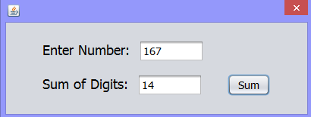
Program 20

Objective: Understanding the use of loops and mathematical operations.

Task: Develop an application to compute the sum of digits for given number.

Code:
int a;
int b=0;
long n;
n=Long.parseLong(ta1.getText());

while(n>0)
{ a=(int)(n%10);
b=b+a;
n=n/10;
}
ta2.setText(""+b);

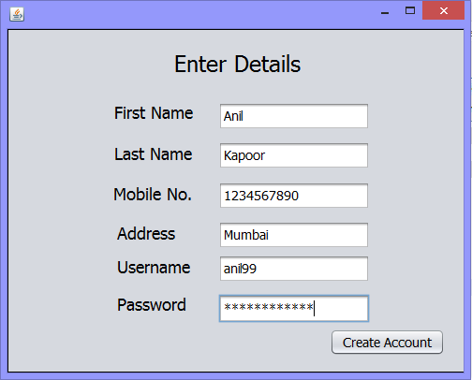
Program 21

Objective : Understanding the Database Handling in JAVA application.

Task: Develop an application which saves user entered data in a mysql database.

Code:
String fn =fname.getText();
String ln =lname.getText();
int mob=Integer.parseInt(mobile.getText());
String add =address.getText();
String un =uname.getText();
String pw =pass.getText();

try{
Class.forName("java.sql.Driver");
Connection con=DriverManager.getConnection("jdbc:mysql://localhost/accounts","root","root");

Statement stmt=con.createStatement();

String query= "Insert into records values('"+fn+"' , '"+ln+"' , '"+mob+"' , '"+add+"' , '"+un+"' , '"+pw+"')";

int rs=stmt.executeUpdate(query);

JOptionPane.showMessageDialog(null, "Account Created!");

}
catch(Exception e)
{JOptionPane.showMessageDialog(null,e.getMessage());
}

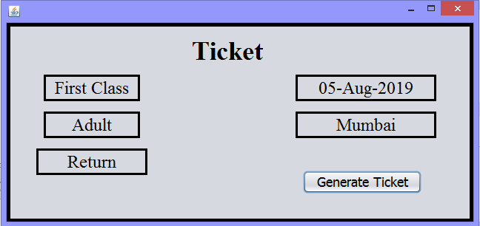
Program 22

Objective : Understanding the Database Handling in JAVA application.

Task: Develop an application which retrives data from a pre-exiting mysql database.

Code:
Calendar timer=Calendar.getInstance();
SimpleDateFormat TDate=new SimpleDateFormat("dd-MMM-yyyy");
Date.setText(TDate.format(timer.getTime()));

try {
Class.forName("java.sql.Driver");
Connection con=DriverManager.getConnection("jdbc:mysql://localhost/accounts","root","root");
Statement stmt=con.createStatement();
String query="select * from main";
ResultSet rs=stmt.executeQuery(query);
while(rs.next())
{
String cls=rs.getString("Class");
String type=rs.getString("Adult");
String dest=rs.getString("Destination");
String typ=rs.getString("Type");

Cls.setText(""+cls);
Ad.setText(""+type);
Dest.setText(""+dest);
Type.setText(""+typ);
}
}
catch(Exception e)
{
JOptionPane.showMessageDialog(this,e.getMessage());
}

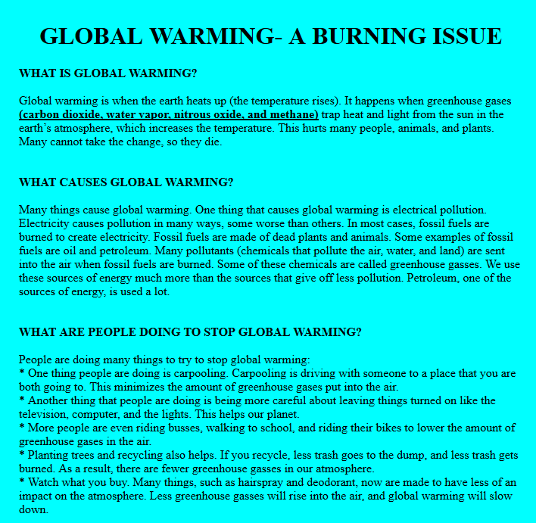

Program 23

Objective : Understanding the Web Page and use of different Tags and attributes.

Task : Create a webpage describing global warming.

Code :
<HTML>
<HEAD>
<TITLE>GLOBAL WARMING</TITLE>
<H1><CENTER>GLOBAL WARMING- A BURNING ISSUE</CENTER></H1>
</HEAD>
<BODY TOPMARGIN ="30" LEFTMARGIN="350" RIGHTMARGIN="350" bgcolor="cyan">

<b>WHAT IS GLOBAL WARMING?</b>
<Br>
<Br>
Global warming is when the earth heats up (the temperature rises). It happens when greenhouse gases <b><u>(carbon dioxide, water vapor, nitrous oxide, and methane)</b></u> trap heat and light from the sun in the earth’s atmosphere, which increases the temperature. This hurts many people, animals, and plants. Many cannot take the change, so they die.
<Br>
<BR>
<br>
<b>WHAT CAUSES GLOBAL WARMING?</b>
<Br>
<Br>
Many things cause global warming. One thing that causes global warming is electrical pollution. Electricity causes pollution in many ways, some worse than others. In most cases, fossil fuels are burned to create electricity. Fossil fuels are made of dead plants and animals. Some examples of fossil fuels are oil and petroleum. Many pollutants (chemicals that pollute the air, water, and land) are sent into the air when fossil fuels are burned. Some of these chemicals are called greenhouse gasses. We use these sources of energy much more than the sources that give off less pollution. Petroleum, one of the sources of energy, is used a lot.
<Br>
<br>
<Br>
<b>WHAT ARE PEOPLE DOING TO STOP GLOBAL WARMING?</b>
<Br>
<Br>
People are doing many things to try to stop global warming:
<BR>* One thing people are doing is carpooling. Carpooling is driving with someone to a place that you are both going to. This minimizes the amount of greenhouse gases put into the air.
<BR>* Another thing that people are doing is being more careful about leaving things turned on like the television, computer, and the lights. This helps our planet.
<BR>* More people are even riding busses, walking to school, and riding their bikes to lower the amount of greenhouse gases in the air.
<BR>* Planting trees and recycling also helps. If you recycle, less trash goes to the dump, and less trash gets burned. As a result, there are fewer greenhouse gasses in our atmosphere.
<BR>* Watch what you buy. Many things, such as hairspray and deodorant, now are made to have less of an impact on the atmosphere. Less greenhouse gasses will rise into the air, and global warming will slow
down.

</BODY>
</HTML>

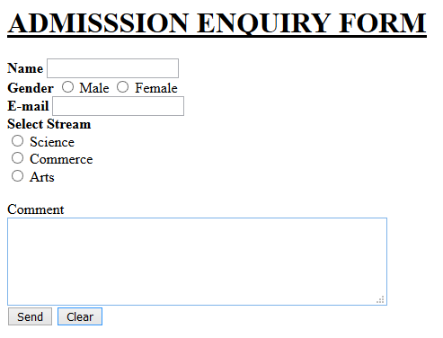
Program 24

Objective: Understanding the Web Form and use of different components to design an interactive form.

Task : Design an admission enquiry form.

Code :
<html>
<head><title> My page </title> </Head>
<body>
<H1> <U>ADMISSSION ENQUIRY FORM </u></h1>
<b>Name </b> <Input type=Text name="st_name"><br>
<b>Gender </b>
<Input type=Radio name="gender" value="Male"> Male
<Input type=Radio name="gender" value="Female"> Female<Br>
<b>E-mail </B><Input type=Text Name ="email"> <br>
<b>Select Stream</b><Br>
<Input type=Radio name="a" value="Science"> Science<Br>
<Input type=Radio name="b" value="Commerce"> Commerce<Br>
<Input type=Radio name="c" value="Arts"> Arts<Br>
</SELECT> <Br>
Comment<Br>
<TextAREA name="comment" Rows=5 cols=50> </TEXTAREA><br>
<INPUT Type="Submit" Value="Send">
<INPUT Type="Reset" Value ="Clear">
</Form>
</body>
</html>

